New Building Progress Report – December

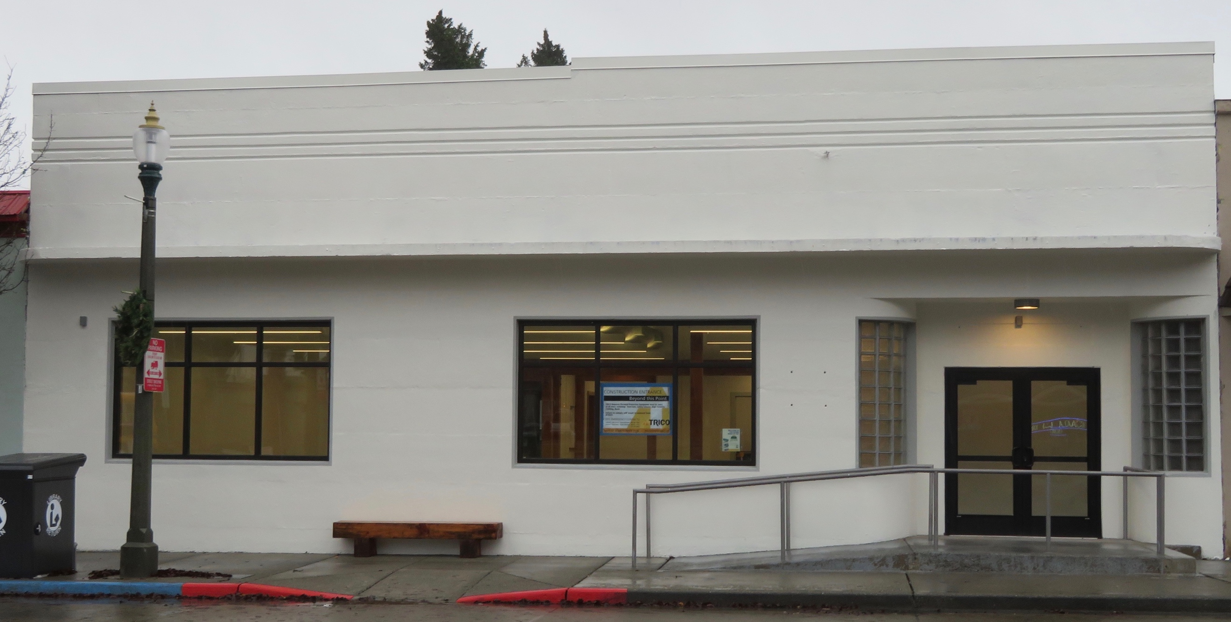

The building is almost completely painted! Some warm dry weather will later allow the final striping in front.

In addition, the back awnings were installed with heat pumps being placed on top. This, along with the now installed propane tanks, will keep the new library cozy and warm all winter days.

Many smaller items were completed such as electrical and data lines, acoustical tiles allowing for significantly quieter rooms, new roof vents added for better ventilation for bathrooms, LED lights installed and turned on that give an amazing change to all the rooms at very little operating costs.

Best of all, a new carpet was installed throughout the building. Blue areas will designate public space and yellow carpet is the staff work areas.

Finally, two weeks of “flushing out” was done for the health of all . . . once occupied.

