New Building Progress Report – January - February

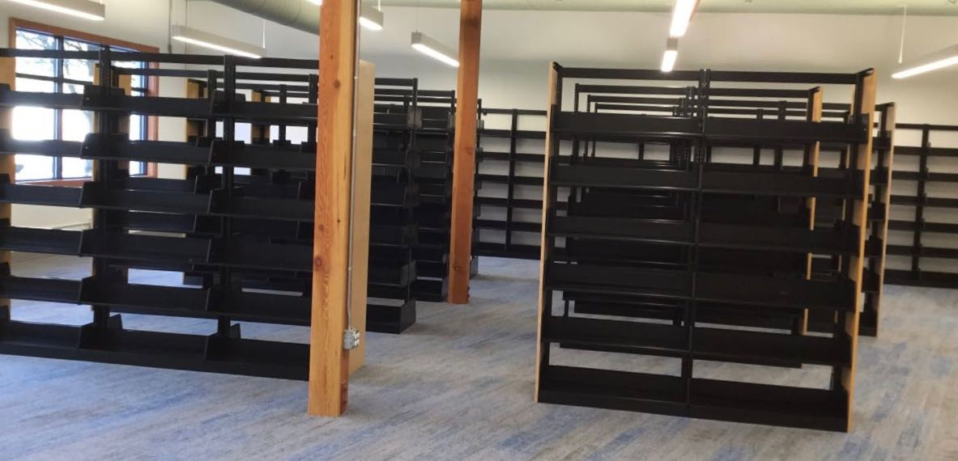

Shelving!

Shelving has been fully installed and bolted to the floor with the placement and heights and types to the staffs’ desires. The front counter is also set up and secured to the floor.

This finished the major work of all contractors. Shortly afterwards, a final walkthrough happened with a minor punch list created. Then, a few days later . . .

. . . **Final sign-off happened!!!** w

The task of moving then began with earnest!

There was much moving of furniture, boxes, technology, etc. into the new building.

As the month ended, the new library become the new home for the Upper Skagit Library.